MFA Instructions

February 2, 2023

To install MFA on your phone, follow the 16 steps (below) and then email [helpdesk@collegeofidaho.edu](mailto:helpdesk@collegeofidaho.edu) after you are setup. To get ready you need both a PC (or laptop) and a cell phone.

**Start on a College of Idaho PC or your personal laptop**

1. Close any open MS Office documents and email on your phone and PC. A PC reboot is a good idea, but not required.
2. Open a Browser (Chrome). Sign into Office.com with your College email and password.
3. Go to “My Security Info” in Office <https://mysignins.microsoft.com/security-info>
4. Click the plus sign on “Add a sign-in” Method

cid:image001.jpg@01D93578.6E2F94E0

1. Select “Add a Method” then Choose “Authenticator App”

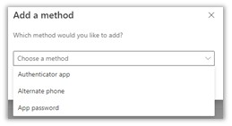

1. Either, get the Microsoft Authenticator app on your phone (recommended) or select “I want to use a different authenticator app” as shown

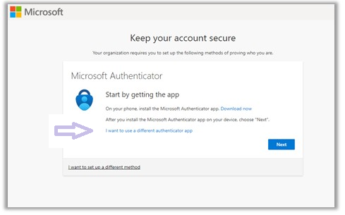

**NEXT On your phone**

1. Download Microsoft Authenticator and Open it
2. Add a new Account
3. use a QR code

**Back on PC**

1. On this screen click next

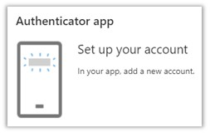

1. You will see a QR code, point your phone with Authenticator at the QR code.
2. The two apps will sync and then test that the Authenticator is working.
3. If everything to good, your PC will show the success
4. Let us know that everything is setup, and we will enforce MFA for you (behind the scenes)

**Back on the Phone**

1. You will be prompted to reauthenticate with MFA on Google Authenticator after you are MFA enforced. So the next time you open your email application where you get College email on your phone, look for a prompt to sign-in at the bottom of the application.
2. Done